**BANK LOAN QUERY REPORT**

**KPI’S:**

1. **Total Loan Application:**

SELECT COUNT(id) AS Total_loan_application FROM financial_loan



1. **Month To Date Loan Application**

SELECT COUNT(id) AS MTD_loan_application FROM financial_loan

WHERE MONTH(issue_date) = 12 AND YEAR(issue_date) = 2021



1. **Total Funded Loan Amount**

SELECT SUM(loan_amount) AS Total_Funded_Amount FROM financial_loan



1. **MTD Loan Amount**

SELECT SUM(loan_amount) AS Total_Funded_Amount FROM financial_loan

WHERE MONTH(issue_date) = 12 AND YEAR(issue_date) =2021



1. **PMTD LOAN AMOUNT**

SELECT SUM(loan_amount) AS Total_Funded_Amount FROM financial_loan

WHERE MONTH(issue_date) = 11 AND YEAR(issue_date) =2021



1. **MTD Total Amount Received**

SELECT SUM(total_payment) AS MTD_Total_Payment_Received FROM financial_loan

WHERE MONTH(issue_date) = 12



1. **PMTD Total Amount Received**

SELECT SUM(total_payment) AS PMTD_Total_Payment_Received FROM financial_loan

WHERE MONTH(issue_date) = 11



1. **Average Interest Rate**

SELECT ROUND(AVG(int_rate),4) * 100 AS Average_Interest_Rate FROM financial_loan



1. **MTD_average Interste Rate**

SELECT ROUND(AVG(int_rate),4) * 100 AS MTD_Average_Interest_Rate FROM financial_loan

WHERE MONTH(issue_date) = 12



1. **PMTD_Average_interst_rate**

SELECT ROUND(AVG(int_rate),4) * 100 AS PMTD_Average_Interest_Rate FROM financial_loan

WHERE MONTH(issue_date) = 11



1. **AVERAGE DTI (debt- income_ratio)**

SELECT ROUND(AVG(dti),4) * 100 AS Average_DTI FROM financial_loan



1. **MTD Avergae DTI**

SELECT ROUND(AVG(dti),4) * 100 AS MTD_Average_DTI FROM financial_loan

WHERE MONTH(issue_date) = 12



1. **PMTD Avergae DTI**

SELECT ROUND(AVG(dti),4) * 100 AS PMTD_Average_DTI FROM financial_loan

WHERE MONTH(issue_date) = 11



**Performing vs non-performing loan**

1. **performing loan percentage**

(COUNT(CASE WHEN loan_status = 'Fully Paid' OR loan_status = 'Current' THEN id END) * 100)

/

COUNT(id) AS Performing_Loan_percentage

FROM financial_loan



1. **Total performing loan application**

SELECT COUNT(id) AS Performing_loan FROM financial_loan

WHERE loan_status = 'Fully Paid' OR loan_status = 'Current'



1. **Performing loan funded amount**

SELECT SUM(loan_amount) AS Performing_loan_funded_amount FROM financial_loan

WHERE loan_status = 'Fully Paid' OR loan_status = 'Current'



1. **Performing loan received amount**

SELECT SUM(total_payment) AS Performing_loan_received_amount FROM financial_loan

WHERE loan_status = 'Fully Paid' OR loan_status = 'Current'



1. **Non-performing loan Percentage**

SELECT

(COUNT(CASE WHEN loan_status = 'Charged Off' THEN id END) * 100.0)

/

COUNT(id) AS Non_Performing_loan_percentage

FROM financial_loan



1. **Total_application for non-performing loan application**

SELECT COUNT(id) AS Non_Performing_loan_Application FROM financial_loan

WHERE loan_status = 'Charged Off'



**20. Total amount funded for non-performing loan application**

SELECT SUM(loan_amount) AS Non_performing_Funded_amount FROM financial_loan

WHERE loan_status = 'Charged Off'



**21. Total amount received from non-performing loan application**

SELECT SUM(total_payment) AS Non_performing_Received_amount FROM financial_loan

WHERE loan_status = 'Charged Off'



**22. Loan status**

SELECT

loan_status,

COUNT(id) AS Total_Application,

SUM(loan_amount) AS TotaL_Funded_Amount,

SUM(total_payment) AS TotaL_Received_Amount,

AVG(int_rate) AS Average_interest_rate,

AVG(dti) AS Average_DTI_rate

FROM financial_loan

GROUP BY loan_status

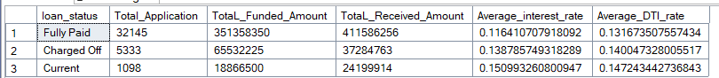

**23. MTD_LOAN_STATUS**

SELECT

loan_status,

COUNT(id) AS MTD_Total_Application,

SUM(loan_amount) AS MTD_TotaL_Funded_Amount,

SUM(total_payment) AS MTD_TotaL_Received_Amount

FROM financial_loan

WHERE MONTH(issue_date) = 12

GROUP BY loan_status

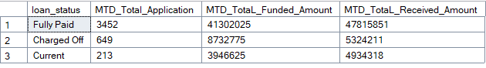

**24. Loan_status_each month**

SELECT

MONTH(issue_date) AS Month_Number,

DATENAME(MONTH, issue_date) AS Month_Name,

COUNT(id) AS MTD_Total_Application,

SUM(loan_amount) AS TotaL_Funded_Amount,

SUM(total_payment) AS MTD_TotaL_Received_Amount

FROM financial_loan

GROUP BY MONTH(issue_date), DATENAME(MONTH, issue_date)

ORDER BY MONTH(issue_date)

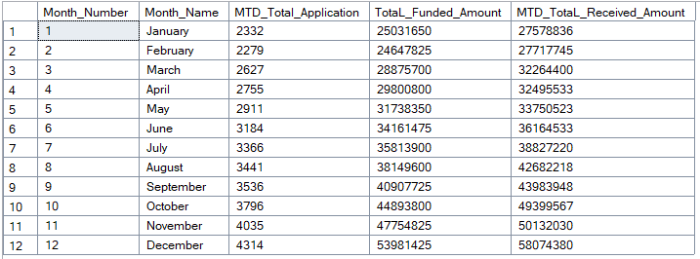

**25. Loan status by address state**

SELECT

address_state,

COUNT(id) AS Total_loan_Application,

SUM(loan_amount) AS Total_funded_loan_amount,

SUM(total_payment) AS Total_Received_loan_amount

FROM financial_loan

GROUP BY address_state

ORDER BY address_state

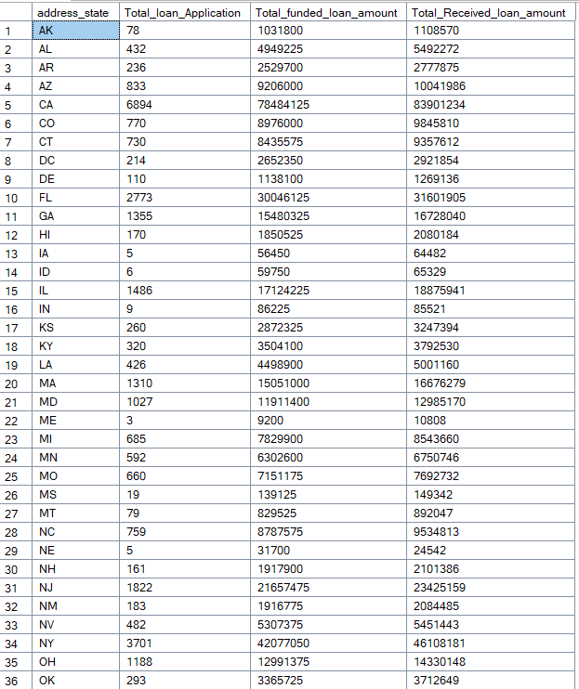

**26. Loan term analysis**

SELECT

term,

COUNT(id) AS Total_loan_Application,

SUM(loan_amount) AS Total_funded_loan_amount,

SUM(total_payment) AS Total_Received_loan_amount

FROM financial_loan

GROUP BY term

ORDER BY term

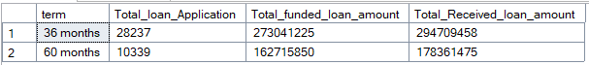

**27. loan based on employee length**

SELECT

emp_length,

COUNT(id) AS Total_loan_Application,

SUM(loan_amount) AS Total_funded_loan_amount,

SUM(total_payment) AS Total_Received_loan_amount

FROM financial_loan

GROUP BY emp_length

ORDER BY emp_length DESC

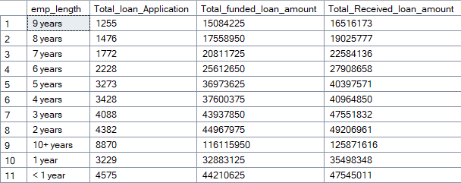

**28.loan status based on purpose of loan**

SELECT

purpose,

COUNT(id) AS Total_loan_Application,

SUM(loan_amount) AS Total_funded_loan_amount,

SUM(total_payment) AS Total_Received_loan_amount

FROM financial_loan

GROUP BY purpose

ORDER BY purpose DESC

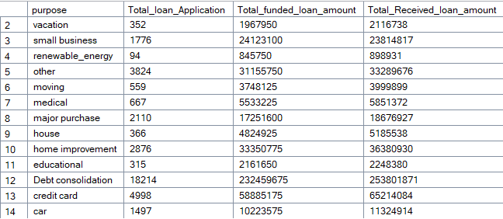

**29. loan status based on grade**

SELECT

grade,

COUNT(id) AS Total_loan_Application,

SUM(loan_amount) AS Total_funded_loan_amount,

SUM(total_payment) AS Total_Received_loan_amount

FROM financial_loan

GROUP BY grade

ORDER BY grade ASC

